1.1)

% Constant 1/(4*pi*epsilon_0) = 9*10^9

k = 9*10^9;

% Enter the Relative permittivity

eps_r = 1;

charge_order = 10^-9; % milli, micro, nano etc..

const = k*charge_order/eps_r;

% Enter the dimensions

Nx = 100; % For 1 meter

Ny = 100; % For 1 meter

% Enter the number of charges.

n = 2;

% Electric fields Initialization

E_f = zeros(Nx,Ny);

Ex = E_f;

Ey = E_f;

% Vectors initialization

ex = E_f;

ey = E_f;

r = E_f;

r_square = E_f;

% Array of charges

Q = [1,-1];

% Array of locations

X = [0,10];

Y = [0,10];

%-------------------------------------------------------------------------%

% COMPUTATION OF ELECTRIC FIELDS

%-------------------------------------------------------------------------%

% Repeat for all the 'n' charges

for k = 1:n

q = Q(k);

% Compute the unit vectors

for i=1:Nx

for j=1:Ny

r_square(i,j) = (i-51-X(k))^2+(j-51-Y(k))^2;

r(i,j) = sqrt(r_square(i,j));

ex(i,j) = ex(i,j)+(i-51-X(k))./r(i,j);

ey(i,j) = ey(i,j)+(j-51-Y(k))./r(i,j);

end

end

E_f = E_f + q.*const./r_square;

Ex = Ex + E_f.*ex.*const;

Ey = Ex + E_f.*ey.*const;

end

%-------------------------------------------------------------------------%

% PLOT THE RESULTS

%-------------------------------------------------------------------------%

x_range = (1:Nx)-51;

y_range = (1:Ny)-51;

%%contour_range = -8:0.02:8;

%%contour(x_range,y_range,E_f',contour_range,'linewidth',0.7);

axis([-15 15 -15 15]);

colorbar('location','eastoutside','fontsize',12);

xlabel('x ','fontsize',14);

ylabel('y ','fontsize',14);

title('Electric field distribution, E (x,y) in V/m','fontsize',14);

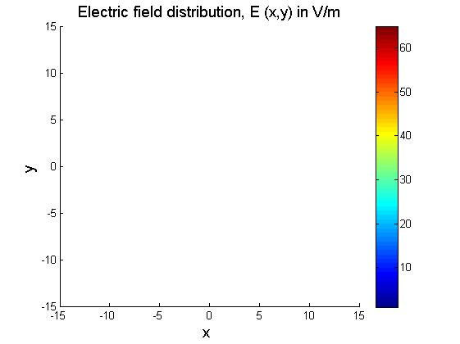

1.2)

% Constant 1/(4*pi*epsilon_0) = 9*10^9

k = 9*10^9;

% Enter the Relative permittivity

eps_r = 1;

charge_order = 10^-9; % milli, micro, nano etc..

const = k*charge_order/eps_r;

% Enter the dimensions

Nx = 100; % For 1 meter

Ny = 100; % For 1 meter

% Enter the number of charges.

n = 2;

% Electric fields Initialization

E_f = zeros(Nx,Ny);

Ex = E_f;

Ey = E_f;

% Vectors initialization

ex = E_f;

ey = E_f;

r = E_f;

r_square = E_f;

% Array of charges

Q = [1,-1];

% Array of locations

X = [0,10];

Y = [0,10];

%-------------------------------------------------------------------------%

% COMPUTATION OF ELECTRIC FIELDS

%-------------------------------------------------------------------------%

% Repeat for all the 'n' charges

for k = 1:n

q = Q(k);

% Compute the unit vectors

for i=1:Nx

for j=1:Ny

r_square(i,j) = (i-51-X(k))^2+(j-51-Y(k))^2;

r(i,j) = sqrt(r_square(i,j));

ex(i,j) = ex(i,j)+(i-51-X(k))./r(i,j);

ey(i,j) = ey(i,j)+(j-51-Y(k))./r(i,j);

end

end

E_f = E_f + q.*const./r_square;

Ex = Ex + E_f.*ex.*const;

Ey = Ex + E_f.*ey.*const;

end

%-------------------------------------------------------------------------%

% PLOT THE RESULTS

%-------------------------------------------------------------------------%

x_range = (1:Nx)-51;

y_range = (1:Ny)-51;

contour_range = -8:0.02:8;

contour(x_range,y_range,E_f',contour_range,'linewidth',0.7);

axis([-15 15 -15 15]);

colorbar('location','eastoutside','fontsize',12);

xlabel('x ','fontsize',14);

ylabel('y ','fontsize',14);

title('Electric field distribution, E (x,y) in V/m','fontsize',14);

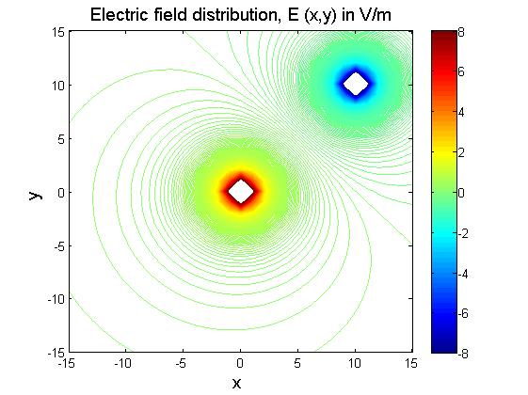

1.3)

% Constant 1/(4*pi*epsilon_0) = 9*10^9

k = 9*10^9;

% Enter the Relative permittivity

eps_r = 1;

charge_order = 10^-9; % milli, micro, nano etc..

const = k*charge_order/eps_r;

% Enter the dimensions

Nx = 100; % For 1 meter

Ny = 100;% For 1 meter

Nz=100;

% Enter the number of charges.

n = 2;

% Electric fields Initialization

E_f = zeros(Nx,Ny);

Ex = E_f;

Ey = E_f;

Ez=E_f;

% Vectors initialization

ex = E_f;

ey = E_f;

ez= E_f;

r = E_f;

r_square = E_f;

% Array of charges

Q = [1,-1,1];

% Array of locations

X = [10,20,30];

Y = [10,20,30];

Z = [10,20,30];

%-------------------------------------------------------------------------%

% COMPUTATION OF ELECTRIC FIELDS

%-------------------------------------------------------------------------%

% Repeat for all the 'n' charges

for k = 1:n

q = Q(k);

% Compute the unit vectors

for i=1:Nx

for j=1:Ny

r_square(i,j) = (i-51-X(k))^2+(j-51-Y(k))^2;

r(i,j) = sqrt(r_square(i,j));

ex(i,j) = ex(i,j)+(i-51-X(k))./r(i,j);

ey(i,j) = ey(i,j)+(j-51-Y(k))./r(i,j);

end

end

E_f = E_f + q.*const./r_square;

Ex = Ex + E_f.*ex.*const;

Ey = Ex + E_f.*ey.*const;

Ez = Ex + E_f.*ey.*const;

end

%-------------------------------------------------------------------------%

% PLOT THE RESULTS

%-------------------------------------------------------------------------%

x_range = (1:Nx)-51;

y_range = (1:Ny)-51;

z_range = (1:Nz)-51;

%%contour_range = -10:0.02:10;

%%contour(x_range,y_range,E_f',contour_range,'linewidth',0.7);

axis([-15 15 -15 15]);

colorbar('location','eastoutside','fontsize',12);

xlabel('x ','fontsize',14);

ylabel('y ','fontsize',14);

title('Electric field distribution, E (x,y) in V/m','fontsize',14);



1.4)

% Constant 1/(4*pi*epsilon_0) = 9*10^9

k = 9*10^9;

% Enter the Relative permittivity

eps_r = 1;

charge_order = 10^-9; % milli, micro, nano etc..

const = k*charge_order/eps_r;

% Enter the dimensions

Nx = 100; % For 1 meter

Ny = 100;% For 1 meter

Nz=100;

% Enter the number of charges.

n = 2;

% Electric fields Initialization

E_f = zeros(Nx,Ny);

Ex = E_f;

Ey = E_f;

Ez=E_f;

% Vectors initialization

ex = E_f;

ey = E_f;

ez= E_f;

r = E_f;

r_square = E_f;

% Array of charges

Q = [1,-1,1];

% Array of locations

X = [10,20,30];

Y = [10,20,30];

Z = [10,20,30];

%-------------------------------------------------------------------------%

% COMPUTATION OF ELECTRIC FIELDS

%-------------------------------------------------------------------------%

% Repeat for all the 'n' charges

for k = 1:n

q = Q(k);

% Compute the unit vectors

for i=1:Nx

for j=1:Ny

r_square(i,j) = (i-51-X(k))^2+(j-51-Y(k))^2;

r(i,j) = sqrt(r_square(i,j));

ex(i,j) = ex(i,j)+(i-51-X(k))./r(i,j);

ey(i,j) = ey(i,j)+(j-51-Y(k))./r(i,j);

end

end

E_f = E_f + q.*const./r_square;

Ex = Ex + E_f.*ex.*const;

Ey = Ex + E_f.*ey.*const;

Ez = Ex + E_f.*ey.*const;

end

%-------------------------------------------------------------------------%

% PLOT THE RESULTS

%-------------------------------------------------------------------------%

x_range = (1:Nx)-51;

y_range = (1:Ny)-51;

z_range = (1:Nz)-51;

contour_range = -10:0.02:10;

contour(x_range,y_range,E_f',contour_range,'linewidth',0.7);

axis([-15 15 -15 15]);

colorbar('location','eastoutside','fontsize',12);

xlabel('x ','fontsize',14);

ylabel('y ','fontsize',14);

title('Electric field distribution, E (x,y) in V/m','fontsize',14);

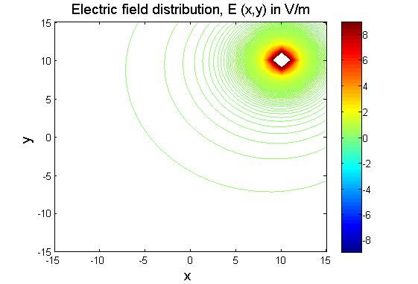

1.5)

% Constant 1/(4*pi*epsilon_0) = 9*10^9

k = 9*10^9;

% Enter the Relative permittivity

eps_r = 1;

charge_order = 10^-9; % milli, micro, nano etc..

const = k*charge_order/eps_r;

% Enter the dimensions

Nx = 100; % For 1 meter

Ny = 100;% For 1 meter

Nz=100;

% Enter the number of charges.

n = 2;

% Electric fields Initialization

E_f = zeros(Nx,Ny);

Ex = E_f;

Ey = E_f;

Ez=E_f;

% Vectors initialization

ex = E_f;

ey = E_f;

ez= E_f;

r = E_f;

r_square = E_f;

% Array of charges

Q = [1,-1,1];

% Array of locations

X = [10,20,30];

Y = [10,20,30];

Z = [10,20,30];

%-------------------------------------------------------------------------%

% COMPUTATION OF ELECTRIC FIELDS

%-------------------------------------------------------------------------%

% Repeat for all the 'n' charges

for k = 1:n

q = Q(k);

% Compute the unit vectors

for i=1:Nx

for j=1:Ny

r_square(i,j) = (i-51-X(k))^2+(j-51-Y(k))^2;

r(i,j) = sqrt(r_square(i,j));

ex(i,j) = ex(i,j)+(i-51-X(k))./r(i,j);

ey(i,j) = ey(i,j)+(j-51-Y(k))./r(i,j);

end

end

E_f = E_f + q.*const./r_square;

Ex = Ex + E_f.*ex.*const;

Ey = Ex + E_f.*ey.*const;

Ez = Ex + E_f.*ey.*const;

end

%-------------------------------------------------------------------------%

% PLOT THE RESULTS

%-------------------------------------------------------------------------%

x_range = (1:Nx)-51;

y_range = (1:Ny)-51;

z_range = (1:Nz)-51;

contour_range = -10:0.02:10;

contour(x_range,y_range,E_f',contour_range,'linewidth',0.7);

axis([-15 15 -15 15]);

colorbar('location','eastoutside','fontsize',12);

xlabel('x ','fontsize',14);

ylabel('y ','fontsize',14);

xmax('x ','fontsize',14);

ymax('y ','fontsize',14);

zmax('z','fontsize',14);

title('Electric field distribution, E (x,y) in V/m','fontsize',14);

